Nepal college of Information TECHNOLOGY

Level: Bachelor | Semester –Fall | Year : 2015
Programme: BE-Software |  | Full Marks : 100
Course: Analysis & Design of Algorithm |  | Time : 3hrs.

Candidates are required to give their answers in their own words as far as practicable.
The figures in the margin indicate full marks.

Attempt all the questions.

Attempt all the questions.
1 | a) What do you mean by an Algorithm? Explain Randomized algorithm with an example.  b) Briefly explain circular queue? Write down the algorithm to insert and delete item in a circular queue. |  |  | 8  7
2 | a) What type of data structures are disjoint set unions. What is a degenerate tree, how do you avoid the formation of degenerate tree?  b) Explain randomized quick sort along with its running time. |  |  | 8  7
3 | a) Computer the running time of conventional matrix multiplication and how would you improve the running time with Strassen’s Algorithm for matrix multiplication.  b) What do you understand by dynamic programming? Compare it with the greedy method of problem solving. |  |  | 8  7
4 | a) Consider the following directed graph where four cities 1-4 are give along with the travelling cost. Find the minimum cost of travelling all the cities starting from 1.  0 10 15 20  1  2  4  3  5 0 9 10  6 13 0 12  8 8 9 0  b) Find optimal solution to 0-1 knap sack problem where number of element n=4 and the size of knapsack=5 for following items using dynamic programming.  - W=2 2. W=3 3.W=4 4. W=5  V=3 V=4 V=5 V=6 |  |  | 8  7
5 | a) Explain optimal merge pattern problem. How can you use greedy method to solve this problem?  b) Explain graph colouring problem, and write down back tracking algorithm for colouring. |  |  | 7  8
6 | - Discuss the different types of tree traversal techniques. Write the algorithm for preorder traversal.  b) Find the shortest path in the following multistage graph using dynamic programming from vertex 1 to vertex 11.  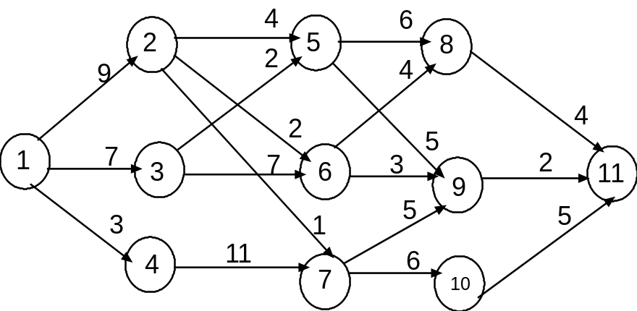 |  |  | 7  8
7 | Write Short notes on (Any two)  - Hamilotinian Cycle  - Asymptotic Notation  - Bi-connected Components |  | 5*2

